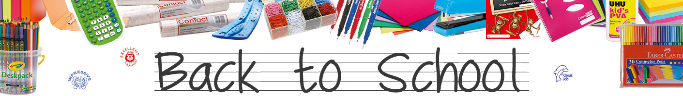
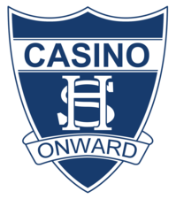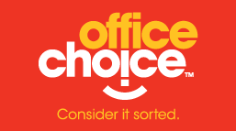
Essential School Equipment Pack 2024
Online Ordering Guide

Dolphin Office Choice is a locally owned and operated company and would like to thank the Casino High School Community for supporting local business.

As a thank you for your support, we will be donating 5% of all sales made back to your school.

To start ordering please note the following:

- Go to: https://dolphin.officechoice.com.au/casinohigh (Click this link or copy this URL into google)
- Select your Year Level from the drop-down menu on the Home Page and adjust item quantities as required.
- Multiple Book Packs can be ordered and supplied in the one delivery. When you complete one order you will be asked if you wish to make an order for another student. Follow the prompts. You will pay for all Bookpacks once when checking out. Bookpacks are supplied separately for each student.
- Pick Up is free from one of our stores (see below). Home Deliveries will incur a $14.95 Charge and will be made ASAP. You can select either option at checkout.

We will phone you when your pack is ready for collection. Stores are open Monday to Friday, 9.00 am to 4.30 pm:

Ballina Ph: 66 864866 47 River Street Ballina
Byron Bay Ph: 66 857097 52 Centennial Ct Byron Bay
Lismore Ph: 66 219066 15 Three Chain Road South Lismore
Mullumbimby Ph: 66 842026 24 Burringbar Street Mullumbimby

Please place you order/s ASAP.
