INFORMATION
BOOKLET
2024

Casino High School

Casino High School
Casino High School

Welcome to Casino High School
There are many new students enrolling at Casino High School in any one year. Whether they are entering Year 7 and commencing their high school life or changing schools after relocating to Casino, it is important to us that they feel welcomed.
An important way in which we can do this is to ensure that students and parents have access to basic information on “how things work” in our school.
Our school has a Positive Behaviour for Learning Program. With this program we have identified four school values – Be Respectful, Be Inclusive, Be Safe and Put in Effort. We expect all students to conduct themselves appropriately at school and follow these school rules.
Important people to assist you when you enrol at Casino High School are your Year Adviser and your Deputy Principal.
This booklet is designed to assist your transition into our school to be effective and enjoyable.

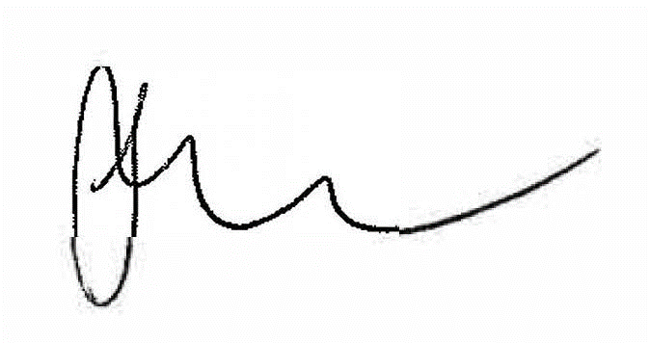
Mrs Minnie Wilson
Acting Principal

Mrs Wilson  Acting Principal | Ms Kearney  Deputy Principal  Years 7, 9 & 11 | Miss Bennett  Deputy Principal  Years 8, 10 & 12 | Ms Garrard  Deputy Principal  Inclusion & Support

Contents
Welcome to Casino High School 3
School Map 5
Term Dates 2024 6
Enrolment Procedures 6
Visiting the School 6
Year 6-7 Enrolment Procedures 6
Parking on the Grounds 6
Transport 7
Parent and Teacher Meetings 7
Concerns 7
Supervision Before and After School 7
Late Arrivals and Early Leavers 7
Attendance 8
Sick and Injured Students 8
Lunch Passes 8
Mobile Phone Pouches 8
Subject Requirements and Personal Property 9
Homework 9
The Hub - School Library 9
Newsletters 9
Socials 9
Assemblies and Awards 10
Public Speaking and Debating 10
Student Representative Council 10
School Development Days 10
Parents and Citizens Association 10
School Bytes App 10
Parent Portal 11
Key Learning Areas 11
Current Courses of Study Offered 12
Vocational Education and Training(VET) and School 13
Higher School Certificate 13
Assessment of Studies 13
Excursions 13
Special Religious Education 13
Sport and Physical Education 14
School Gym 14
Contributions 15
Year Advisers 16
Careers Adviser 16
Aboriginal Education Officer (AEO) 16
Counsellor Service 17
Supervisor of Female Students 17
Vaccinations 17
Learning and Support Team 19
Student Support Officer 19
Casino High School PBL Values 20
Positive Behaviours for Learning (PBL) 21
PBL Awards 21
Parents and Carers Responsibilities 21
Excursions via Car Travel 21
Racism 21
Student Safety/Movement within School 22
Buildings and Grounds 22
School Uniform 23
Uniform Shop 23
Out of Uniform Procedure 23
Footwear 23
Uniform Requirements 24
Canteen 25
Bell Times 28

School Map
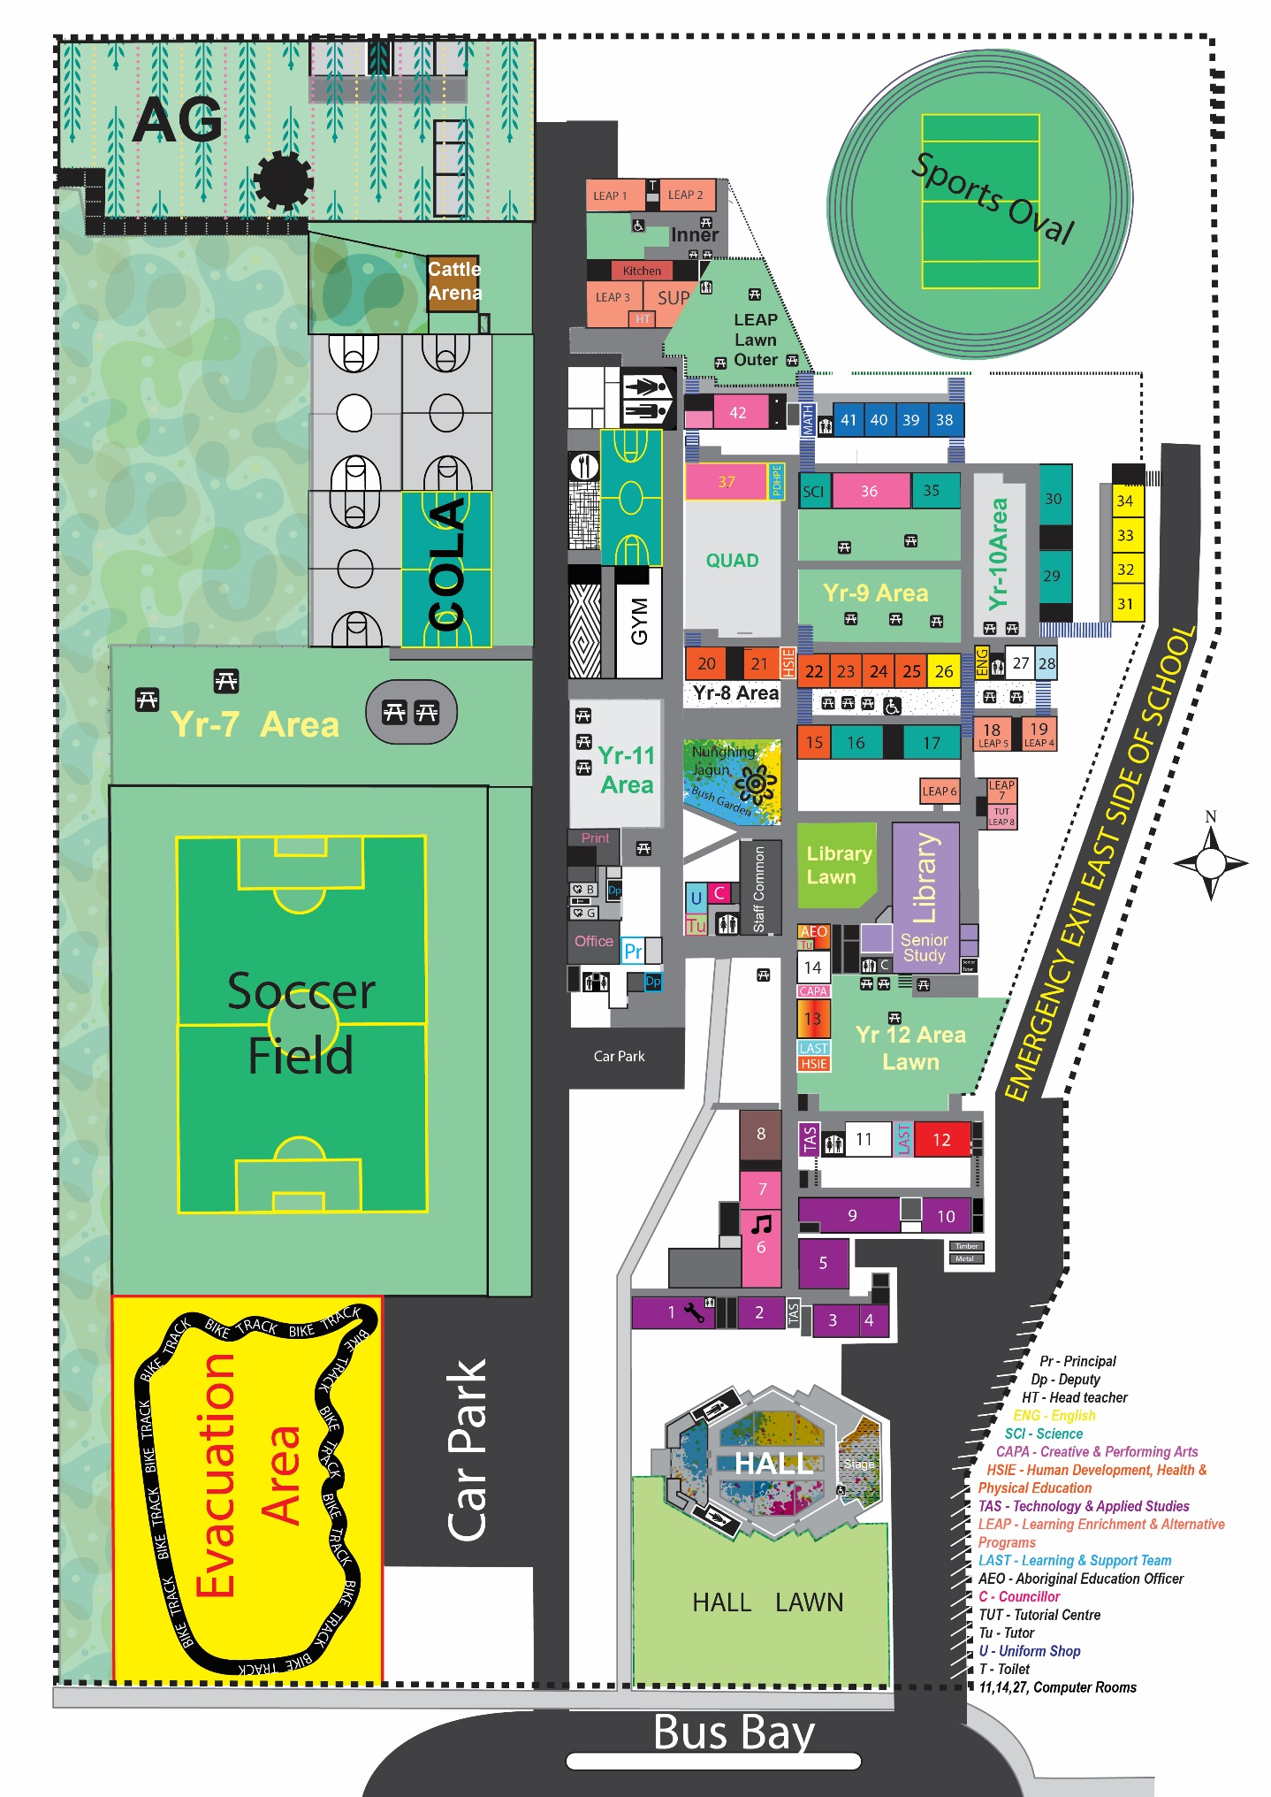

Term Dates 2024

Commencement Dates 2024
School Development Days (Staff only) Tuesday 30 and Wednesday 31 January 2024
Years 7, 11 and 12 Thursday 1 February 2024
All Students Friday 2 February 2024
Schools provide opportunities for staff and school leaders to continually improve their knowledge, skills and professional capability to deliver key curriculum priorities and school strategic directions.

Term Dates
Term 1 30 January to 12 April
Term 2 29 April to 5 July
Term 3 22 July to 27 September
Term 4 14 October to 20 December

Enrolment Procedures
Enrolment applications are available on the school’s website. To apply online your child must be a NSW resident, an Australian or New Zealand citizen or permanent resident and be living in the local enrolment area of the school for which you are submitting an application.
The designated intake areas are determined by the Department of Education and many NSW Government schools have specific local enrolment areas. The Administration Office staff can advise you if you are within our zone. Supporting documentation to verify the student is living in the Casino High School zone will be required and these documents can include rental documents, rates notice, driver’s licence and other forms of documentation. If parents and carers are unable to access the online application process, enrolment applications are available at the School Administration Office.

Year 6-7 Enrolment Procedures
Year 6 students from Government Primary Schools will follow the transition process conducted through their primary school.
Parents and Carers of Year 6 students from non-Government Schools are required to complete an Expression of Interest Form and return it to the School Administration Office together with their student’s birth certificate and proof of address.

Visiting the School
In the interest of student and staff safety, it is a legal requirement that all visitors to the school sign in at the Administration Office electronically using a QR code. Visitors will be given a visitor’s label to wear whilst on site and are also required to sign out on departure.

Parking on the Grounds
When visiting the school, parents and carers are asked to follow the internal signage with regard to parking. Visitor parking is available in the Administration carpark.
Parents and Carers are asked not to enter the grounds whilst delivering or collecting students unless there is an emergency or special reason that has been approved by the school. Parking is limited and the congestion caused by parents and carers entering and leaving the grounds at the beginning and end of the school day is a safety hazard for students and staff.

Transport
Free Travel Pass - the cost of travel on bus lines is paid by the NSW Government, provided students live outside the 2.0 kilometre radius from the school. All new enrolments that travel by bus should complete the online application form at www.transportnsw.info/school-students
A Private Vehicle Conveyance (PVC) Subsidy is available for eligible school students where there is no public transport available for all or part of the journey of more than 1.6km. The PVC Subsidy is paid based on the distance between their home and the nearest transport pick up point or school. The Subsidy may also be available on medical grounds. Apply online at www.transport.nsw.gov.au/schooldrive

Parent and Teacher Meetings
Parent and Teacher meetings are held following the Half Yearly Assessments. Parents and Carers are able to consult with class teachers to discuss their student’s progress.
Other important meetings are held throughout the year and may include information evenings for course selections, motivational speakers, and literacy. We encourage all parents and carers to attend these meetings and information nights.

Concerns
If you are concerned about your student’s progress or wish to pass on information that may assist in your student’s learning, parents and carers are encouraged to contact the teacher concerned or the students Year Adviser by phoning the school to arrange a meeting or request a return phone call.
Other staff members who may assist parents and carers are the Learning and Support Team, Aboriginal Education Officer, School Counsellor, Supervisor of Female Students, Head Teacher of a subject area or a Deputy Principal, all of which may be contacted via the school office.

Supervision Before and After School
On arrival at school in the morning, students are expected to move directly to the quadrangle area. There is no supervision in the school before 8.30am in the morning or after bus supervision at the end of day. Please do not send students to school before 8.30am.

Late Arrivals and Early Leavers
Students who arrive late to school must sign in at the Student Services Counter on arrival with a note of explanation from a parent or carer.
Students are only permitted to leave school before the end of the school day if they have a note signed by their parent or carer. This note must be presented at the Student Services Counter before school begins at the start of the day. Students who have permission to leave the school must have their early leavers slip from the office with them when leaving the school grounds. Please refrain from calling during school hours to sign your student out.
All notes should be written by a parent or carer and clearly state the students name, year, parents, or carer name, contact details and explanation for absence. There are special conditions covering the rights and responsibilities of senior students. These are given to Year 11 and 12 students in a separate Policy Statement.

Attendance
All New South Wales students must complete Year 10 or equivalent. After Year 10, and up until they reach 17 years of age, there are a range of flexible options for students to complete their schooling.
Punctuality and regular attendance are essential for satisfactory progress. Written explanations for all absences should be handed in at the Student Services Counter within seven school days of an absence. If a note or text is not received the absence will remain “unexplained” on the student’s record. This can affect any Centrelink payments as per Department of Education attendance guidelines. The Department of Education’s Home School Liaison Officer (HSLO) regularly monitors the attendance of all students.
Parents and carers of students who are marked absent at roll call will receive a message via SMS if a mobile number is available.

Sick and Injured Students
Students when sick during class time will be sent with a lanyard from their Class Teacher to the office, who will then arrange admission to sick bay.
Office staff will make the student comfortable, assess the situation, provide any necessary first aid and contact the parents or carers. If the student becomes injured or ill during Breaks 1 or 2, the student should report to the teacher on duty who will send the student to the office with a lanyard. In the case of serious injury an ambulance will be called, and first aid provided by a member of staff with a First Aid Certificate until the ambulance arrives.

Lunch Passes
Lunch passes will only be issued to students who live in the close vicinity of Casino High School. Passes will not be issued to students who live on the town side of the railway line. Students wishing to go home for lunch must apply for a lunch pass from the Deputy Principal and the pass is only valid for the student’s home address. The application must be signed by the parent or carer and returned to the Deputy Principal, who will process the pass. Students going home for lunch must return to school before the end of Break 1. Constant lateness will result in the cancellation of the lunch pass.

Mobile Phone Pouches
Each student is assigned a phone pouch even if they do not have a phone and it is expected to be kept in their school bag. Students are required to use the unlocking stations on the external fence at the front gate each morning as they enter to unlock their pouch and place the phone inside. The phones remain locked throughout the day. At the end of the day students leave the school via the exit gates and use the unlocking stations to unlock their pouches. No unlocked phone is permitted on school grounds during school hours unless part of a specific learning experience at the direction of teaching staff.
If a student needs to make a phone call for any purpose, they are to contact their Deputy Principal during break-times to organise this ahead of time. Students who have lost or damaged their pouch are not to bring their phone to school until they have organised a replacement pouch. Students are required to pay $10 for the replacement of the damaged or lost pouch. At points during the school year all students’ phone pouches will be inspected to ensure they are still functional. This is now in line with the NSW governments ban on mobile phones in schools.

Subject Requirements and Personal Property
Year 7 Book Packs and calculators are available for purchase from the Uniform Shop. A booklist for Years 8 to 10 is displayed on the Casino High School Website. The Canteen has a limited supply of pens and exercise books for purchase.
Upon arrival at school, bikes and scooters should be locked to provide adequate security. Helmets must be worn when riding to and from school and remain the responsibility of the rider whilst at school. Skateboards are not an acceptable means of transport and should not be brought to school.

Homework
It is expected that students devote some time each night to written homework or revision of the day’s work. Satisfactory progress requires frequent revision of class work in high school. Students should plan their next day, have all required books/materials for each lesson and any homework, essays, assignments etc. completed and handed in on time.

The Hub - School Library
The Hub is a welcoming and inclusive learning space that contains a digital and print library, photocopying area, reading and quiet games area, Senior Learning Area, Careers Adviser, classroom and tutorial rooms, laptops, and I.C.T help. The Hub is where students’ complete schoolwork, study and quietly relax and read. It is open before school from 8.30 to -9.00 am each day and most breaks. Students can get assistance from the Teacher Librarian, Ms Hatzimanolis, to complete assessment tasks and schoolwork, locate books and acquire resources that suit student interests.
In The Hub, students follow Casino High School’s Positive Behaviours for Learning of RISE.
Respect The Hub space and those around you who are trying to learn and relax
Include diverse interests in your reading and research to broaden your thinking and appreciate the world around you.
Be safe by using equipment and resources correctly as directed
Put in effort to achieve your best.

Newsletters
The School Newsletter is published weekly, it is an important tool to inform parents and carers about current happenings and achievements of our students in the school.
Newsletters are emailed to parents, carers and students and can also be viewed on the school website – https://casino-h.schools.nsw.gov.au. Hard copies of the newsletter are also available from the Office.

Socials
School Socials are held each term, commencing at 6pm and finishing at 9pm. These events may have a theme and are fully supervised, with students not permitted to leave the venue during the social. Parents are required to arrange for their child to travel home at the end of the event. Tickets are on sale at school from the SRC students during Breaks 1 and 2 and must be purchased prior to the social. Students on a discipline level cannot attend socials nor students who have a history of poor behaviour at past socials.

Assemblies and Awards
Whole School Assemblies take place each week where essential information is provided to students and Positive Behaviour for Learning (PBL) is also reinforced. Faculty Achievement Awards are presented to students for their outstanding efforts in class.
Each Semester Formal Academic Assemblies are held for each year group. The Principal’s Award, Year Adviser Award and Academic Excellence Awards are presented to students.
Additionally, there are also Annual Assemblies including the Year 12 Graduation Assembly, Sports Award Assembly, ANZAC and SRC Assemblies. All major assemblies take place in the “The Len Walsh Hall”. Parents and Carers are invited to attend together with dignitaries and sponsoring business houses.

Public Speaking and Debating
All students have an opportunity to participate in class public speaking competitions with year finalists competing for the ‘Gunthorpe Shield’ at the Regional Lions Club meeting. There are also numerous opportunities to participate in interschool debating competitions.

Student Representative Council
The Student Representative Council (SRC) is comprised of elected representatives from each year group that meet regularly to discuss, plan, and actively follow up on student related issues.
The SRC fosters responsible student advocacy, leadership, and community participation across a range of situations. Their opinion is sought on matters regarding the school environment, student wellbeing and issues raised by students regarding the performance of the school. Being a member of the SRC provides students the opportunity to show leadership and have a say in the running of the school.

School Development Days
Staff Development Days enable staff to participate in a range of activities aimed at the overall development of the school. These could include the School Management Plan, setting goals and objectives, curriculum changes, student welfare programs and leadership training etc. Parental involvement in these days is welcome when the program is relevant.

Parents and Citizens Association
Our Parents and Citizens Association (P&C) is made up of parents and carers, teachers, and community members. The P&C meets regularly to contribute to decision-making, develop policies, plan improvements, and support the school.
Meetings are held on the last Thursday of each month at 5pm and are advertised via the School Newsletter. We welcome parents and carers of new and current students to come along and join the Association.

School Bytes App
The School Bytes App enables parents and carers to keep up to date with the latest news, events, and important updates regarding the school. Parents and Carers can complete permission notes, make payments, and update details through the App.
To use the App go to the appropriate App Store, download ‘School Bytes’, open the App, register using your name and email that the school has on file.

Parent Portal
Casino High School has undertaken an initiative to provide parents and carers with discreet information about their student’s progress via access through the Parent Portal. An access key is sent to the parent or carers email address that is registered with the school for each student. To register for access to the Parent Portal the address is
http://web1.casino-h.schools.nsw.edu.au/portal/register. Login with your registered email address to create a username and password.
Once registered access is available via https://web1.casino-h.schools.nsw.edu.au/portal for parents and carers to observe and manage their children’s enrolment at Casino High School.

Key Learning Areas
The NSW School Curriculum is organised into key areas of learning as required by the Education Reform Act, 1990. Teachers provide students with many educational opportunities which help them to learn in more than one Key Learning Area (KLA) at the same time.
There are eight secondary school Key Learning Areas.
- English
- Mathematics
- Science
- Human Society and its Environment (HSIE)
- Languages - Japanese
- Technological and Applied Studies (TAS)
- Creative and Performing Arts (CAPA)
- Personal Development, Health and Physical Education (PDHPE)

This is to comply with the syllabuses for the Australian Curriculum. For more details, contact either of the Deputy Principals.
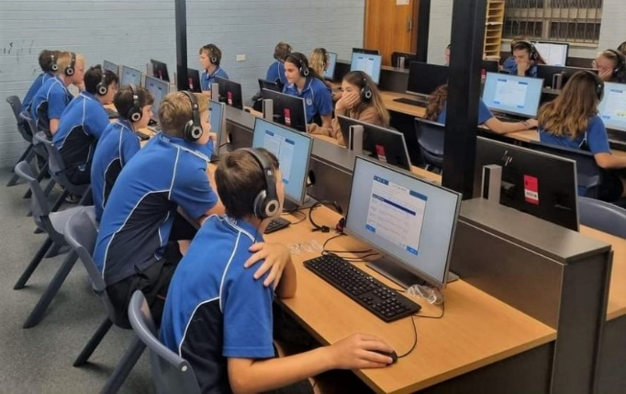

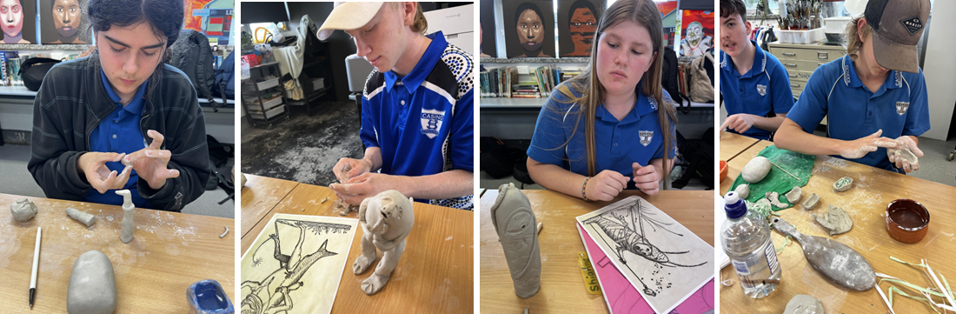

Current Courses of Study Offered
Year 7 | Year 8 | Years 9 & 10 | Years 11 & 12
Mandatory Subjects | Mandatory Subjects | Mandatory Subjects | English Extension
English | English | English | English Advanced
Mathematics | Mathematics | Mathematics | English Standard
Science | PDHPE | Science | English Studies
History and Geography | Science | PDHPE | Mathematics Extension
Music | History and Geography | History and Geography | Mathematics Advanced
Visual Arts | Technology | Elective Subjects: | Mathematics
Technology | Japanese | Aboriginal Studies | Mathematics Standard
PDHPE | Information Literacy | Agriculture | Numeracy
Information Literacy |  | Child Studies | Aboriginal Studies
 |  | Commerce | Biology
 |  | Elective History | Business Studies
 |  | Electronics | Chemistry
 |  | Food Technology | Community and Family Studies
 |  | Industrial Technology Metal | Industrial Technology Timber
 |  | Industrial Technology Timber | Investigating Science
 |  | Music | Legal Studies
 |  | Photography & Digital Media | Modern History
 |  | Physical Activity and Sports Studies | Music
 |  | Textiles Technology | PDHPE
 |  | Visual Arts | Physics
 |  |  | Society and Culture
 |  |  | Sport, Lifestyle & Recreation
 |  |  | Visual Arts
 |  |  | Work Studies
 |  |  | VET Courses:
 |  |  | Construction
 |  |  | Hospitality
 |  |  | Manufacturing
 |  |  | Primary Industries
 |  |  | Retail Services

Vocational Education and Training(VET) and School
VET Courses are available for senior students wanting to study an industry-based pathway as part of the Higher School Certificate. Students can attain a qualification that prepares them for the workforce.
Vocational courses are growing rapidly and are offered both by Casino High School and TAFE NSW. Many of these courses offer students dual accreditation in VET and the HSC.

Higher School Certificate
The Higher School Certificate is the responsibility of the NSW Education Standards Authority (NESA).
The Higher School Certificate is awarded to students who satisfactorily complete the required program of studies for Years 11 and 12. Results are based on school assessments and external examinations.
For further information, contact either of the Deputy Principals or the NSW Education Standards Authority www.educationstandards.nsw.edu.au

Assessment of Studies

Years 7 to 10
A School Report is sent to parents and carers to indicate student progress and achievement at the end of Semester 1 and Semester 2.
Semester Reports contain a series of grades and marks indicating the progress of students in achieving the outcomes prescribed by the NSW Education Standards Authority for that subject.
In each subject, students are advised on how particular outcomes will be assessed and how this will contribute to their achieving at a satisfactory level in the course.
When students fail to complete assessment tasks on time or to a satisfactory standard, parents and carers will be notified.

Years 11 and 12
School Reports following half yearly and yearly examinations are based on examination and assessment task results. The HSC assessment ranking is outlined in the HSC Assessment Policy issued to Year 11 students at the beginning of Term 4.

Excursions
A variety of excursions and sporting trips are organised by the school during the year. Students taking part must be in full school uniform or approved suitable attire and return their signed permission notes promptly.

Special Religious Education
Students in Year 7 and Year 8 can access 1 period per timetable rotation of Special Religious Education (SRE). These lessons are delivered by a specialist teacher who works part time in the school.
The SRE program offered at Casino High School is Christian SRE. Additional details of Christian SRE programs can be obtained from SRE providers and contact details can be provided by the school if required.

Sport and Physical Education
Students in Years 7-10 are required by the Department of Education to participate in a minimum of 150 minutes of planned moderate activity with some vigorous physical activity across the school week.
To meet minimum requirements, students in Years 7-10 are required to participate in both the mandatory Weekly Sport Program and timetabled Physical Education lessons.
Sport and PDHPE play an important role in developing lifelong positive attitudes toward physical activity, building effective communication skills through working with others in team-based activities and enhancing fitness and self-confidence.
Weekly Sport begins at 1.45pm on Wednesdays, where students are provided a diverse selection of sporting activities utilising both school-based facilities and venues situated within the Casino community. To enable equal access for all, sports are provided at a minimal weekly cost or at no cost to students.
If a student is unable to attend Sport, a note with a valid reason (signed and dated by a parent or carer) must be presented to the Weekly Sports Coordinator for authorisation before 9.00am on Wednesday. All students return to school at the conclusion of sport. Students are not permitted to depart directly from sport.

School Gym
Students have access to a purpose-built teaching and learning facility that supports quality programs across different faculties daily. The school Gym is currently utilised by:
- Years 11/12 PDHPE classes as a Human Performance Lab
- Years 11/12 SLR classes for Personalised Fitness Programs
- LEAP students to develop life skills around fitness and wellbeing
- Tutorial students as part of an integrated fitness program
- Sporting teams during Wednesday School Sport.
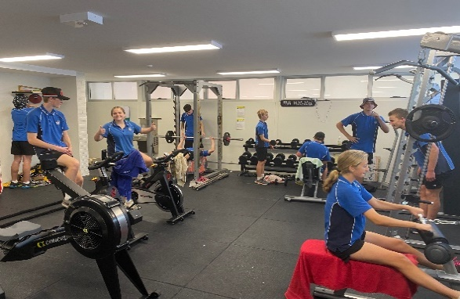
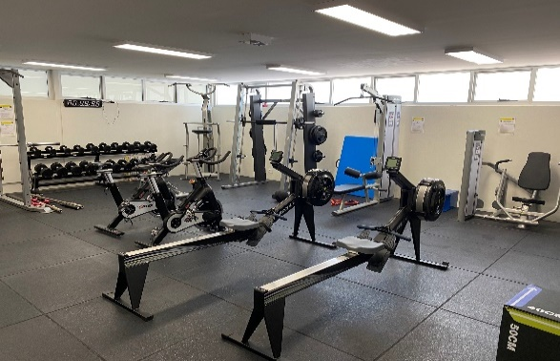
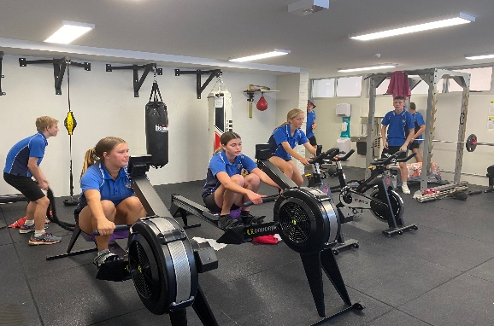
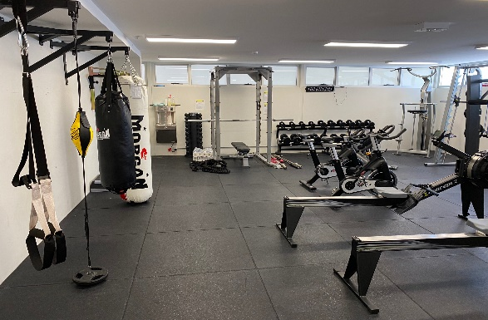

Contributions

Voluntary School Contribution
The Voluntary School Contribution provides additional funds which enable our school to purchase items and equipment, teaching materials and books which support the teaching and learning of our students. The school sends out invoices quarterly and we encourage parents and carers to support the school through this contribution.

Subject Contribution
Subject Contributions specifically cover the cost of consumable items used in elective subjects enabling students to participate in quality practical learning experiences.

Student Assistance
Parents and Carers who cannot pay for subject contributions because of financial hardship may apply for student assistance. Student assistance can also be applied for to help with the costs of uniforms, excursions, and extracurricular activities.
If you require assistance, please contact the administration office or speak to the Principal directly. All student assistance applications remain confidential.
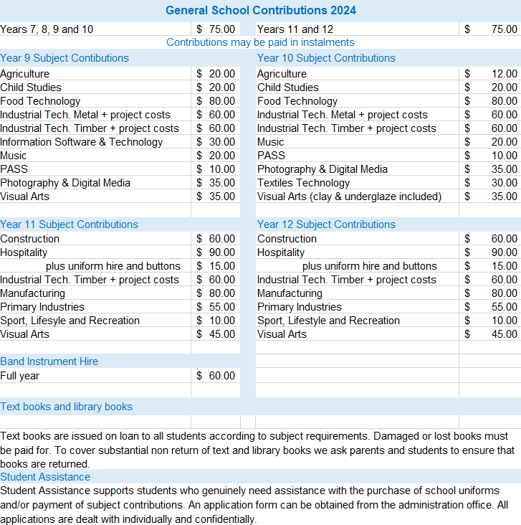

Year Advisers
Year Advisers are assigned at the commencement of Year 7 and continue with that year group throughout their high school years. They assist other staff in maintaining student wellbeing and support the learning of students in their year group. They attend welfare meetings and play a vital role in the welfare network.
Students are encouraged to discuss any concerns they may have with their Year Adviser who will endeavour to provide the appropriate guidance.

2024 Year Advisers
Year 7
Ms Jarvis
Year 8
Miss Evenden
Year 9
Miss Maslen
Year 10
Miss Goode
Wed, Thu, Fri
Year 11
Mr Nicholson
Year 12
Mrs Armbruster
Mon, Tue, Wed

Year 10
Mrs Hill
Mon, Tue
Year 12
Miss Cormick
Thu, Fri

Careers Adviser
The Careers Adviser organises structured career plans for Years 10, 11 and 12. This can include work experience, work-ready programs and school-based traineeships and apprenticeships.
Mrs Weir
The Careers Adviser is available to discuss career pathways and information with all students. This can include career counselling, entry to tertiary institutions such as TAFE and universities, scholarship applications, subject selection, resumes, interview preparation, transition plans and referrals to external agencies.

Aboriginal Education Officer (AEO)
The Aboriginal Education Officer assists Aboriginal Students and their families to support improved learning, welfare, and well-being outcomes for Aboriginal students.
Aunty Liz
The role of the Aboriginal Education Officer is to
- to assist Aboriginal students in all school activities including excursions
- to discuss with Aboriginal parents the educational progress of their children
- to identify and develop resources to support the learning outcomes of Aboriginal students
- to assist in the development and implementation of Aboriginal Cultural programs including Sista and Bro speak and Personalised Learning Pathways
- to support Aboriginal cultural awareness for all students and staff
- to help maintain effective relationships between Aboriginal parents, the Aboriginal community and school staff
The Aboriginal Education Officer works part of the school team, liaises with the principal and staff on various protocols and procedures involving Aboriginal students within the school and community.
All students are encouraged to approach Aunty Liz with any issues that they may need assistance with.

Counsellor Service
The school counselling service contributes to our students’ wellbeing by providing specialised psychological assessments and counselling and intervention services. In addition, the school counselling service contributes to student learning and wellbeing outcomes through membership of school-based learning and support teams. Access to the school counselling service is gained by:
Miss Stone
- self-referral from students
- referral from parents and carers
- referral through the school’s Learning and Support Team
- Principal referral

School based referrals go through the school’s Wellbeing and/or Learning and Support Team. Parents and Carers are informed of these referrals and are required to give permission for the referral to proceed.

Supervisor of Female Students
Mrs Wall
The Supervisor of female students takes an interest in the overall wellbeing of female students. Any female student who feels sick or needs support in any way may approach the supervisor for assistance at any time.
Mrs Wall also coordinates the National School Based Immunisation Program.

Vaccinations
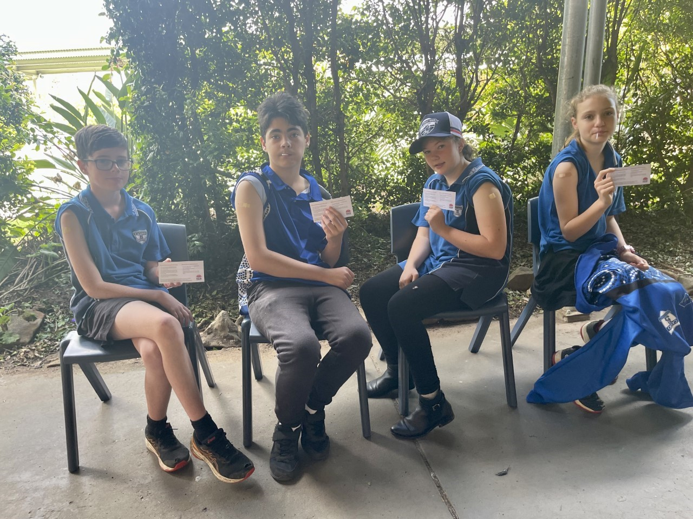
Teams of specially trained registered nurses will visit Casino High School to offer free vaccinations against serious vaccine preventable diseases. At the beginning of the school year, we will share the link to complete the online consent form.

North Coast Public Health
Covering both Mid North Coast & Northern NSW Local Health Districts

2024 Vaccination Schedule

Year 7 Students | Vaccine | Disease | Who is Eligible | How many doses
 | Gardasil | Human Papillomavirus | Year 7 (female and males) | 1
 | Boostrix | Diptheria/Tetanus/Pertussis (Whooping Cough) | Year 7 (female and males) | 1
Year 8 Students (catch up) | Vaccine | Disease | Who is Eligible | How many doses
 | Gardasil | Human Papillomavirus | All Year 7 students who are on a catch up from the previous year ie 2023. | 1
 | Boostrix | Diptheria/Tetanus/Pertussis (Whooping Cough) | All Year 7 students who are on a catch up from the previous year ie 2023. | 1
Year 10 Students | Vaccine | Disease | Who is Eligible | How many doses
 | Nimenrix | Meningococcal ACWY | Years 10 (female and males) | 1
Year 11 Students (catch up) | Vaccine | Disease | Who is Eligible | How many doses
 | Nimenrix | Meningococcal ACWY | All Year 11 students who are on a catch up from the previous year ie 2023. | 1

Learning and Support Team
Our Learning and Support Team is a whole school planning and support mechanism. It is formed with the purpose of addressing the learning and support needs of individual and groups of students through the co-ordination, development, implementation, monitoring and evaluation of educational and welfare programs.
Mrs Wall
Relieving HT Welfare
A prime function of our Learning and Support Team is to ensure that the needs of all students are met. This is achieved through the team facilitating collaborative planning between teachers, support staff, parents, and students. The Learning and Support Team have a scheduled weekly meeting.
Ms Piccoli

The following members are a part of our Learning and Support Team:
- Head Teacher Welfare (Co-ordinator)
- School Counsellor
- Senior Executive
- Learning and Support Teacher (LaST)
- Head Teacher Support
- Student Support Officer
- Aboriginal Education Officer
- Wellbeing and Health In-Reach Nurse (WHIN)

Student Support Officer
Student Support Officers (SSOs) work in schools to enhance the wellbeing and learning outcomes of students. At Casino High School our SSO graduated with a Bachelor of Social Science majoring in Sociology; and is currently enrolled in a Graduate Diploma of Mental Health. She has a long history of supporting student engagement and wellbeing in her roles as Peer Support Leader, Student Mentor, PASS Leader, and Peer Facilitator, which involved working to develop and facilitate a series of online study groups aimed at supporting university students studying online.
Ms Raine

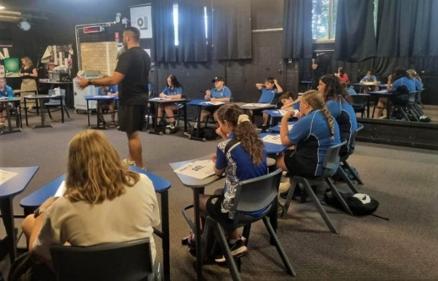
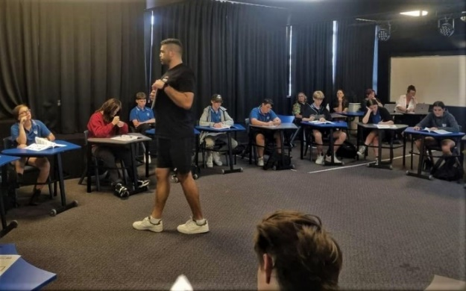
SSO’s work closely with the School Counselling service and the Learning and Support Team supporting the implementation of the school’s whole-of-school approach to wellbeing, helping students develop social and emotional skills through targeted strengths-based programs and promoting strategies that build resilience, coping skills and positive relationships. They also have a pivotal role in working collaboratively with external and other government agencies in their support of students and their families.

Casino High School PBL Values
 | Respectful | Inclusive | Safe | Effort
All Settings | - Follow staff instructions  - Use school talk  - Value all property  - Use manners  - Listen politely | - Be kind  - Be tolerant  - Accept others  - Be fair  - Be patient | - Right place, right time  - Stay in bounds  - Keep hands and feet to self  - Use equipment appropriately  and for its purpose | - Put rubbish in bin  - Out of class, need a pass  - Wear school uniform  - Listen to announcements
Playground Settings | - Be aware of others  around you | - Show sportsmanship | - Non-contact sports  - Be sun safe | - Follow game  expectations
Transition Settings | - Go quietly to class at  the first bell  - Keep hands and feet  to self  - Walk on the left | - Share the space  - Be patient | - Line up against the wall  - Walk  - Remain on school  grounds | - Phones away  - Return to class promptly
School Class Rooms and School Events | - Phone and earphones  off and out of sight  - Hoodies off  - Knock on door before  entering  - Respect other peoples  space and privacy | - Allow others to learn  - Be helpful to peers  and staff  - Encourage your peers  - Welcome visitors | - Enter spaces in an orderly  manner  - Keep doorways clear  - Use designated pathways  for all venues | - Be on time  - Be a learner  - Bring correct equipment  - Stay in designated areas

Positive Behaviours for Learning (PBL)
Casino High School is an established PBL (Positive Behaviour for Learning) school. This means that we have agreed upon four core values which underpin all expected behaviours. Our values are Respect, Inclusion, Safety and Effort. Our PBL mascot is the beautiful black swan which frequents this Bundjalung land and represents us individually and as a school always striving to RISE. Each week the whole school participates in a short focus lesson which contributes to the consistent nature of our school wide expectations.

PBL Awards
We regularly award students who are modelling our values and each week student awards are randomly drawn at our school Assembly with the lucky winners receiving $10 Canteen vouchers. Students must collect four awards of each value: Respect, Inclusion, Safety and Effort (16 in total) to be presented the RISE Award. Four further RISE Awards will earn the Black Swan Award presented by the Principal.

Parents and Carers Responsibilities
Casino High School is committed to working with parents and carers in the development of socially acceptable behaviour by students to ensure a positive learning environment. This behaviour will allow students to develop the learning skills required for success in life.
Parents and Carers are responsible for ensuring their children attend school. They share in the responsibility of shaping their children’s understanding and attitudes about acceptable behaviour. This policy aims to help each student to do well at school and to become self-disciplined and self-directed learners. Parents and Carers are expected to support the school in the application of this Discipline Policy.

Excursions via Car Travel
Transporting students in cars to excursions may only occur under the following conditions:
- Parents and carers must be advised and approve of the travel arrangements made
- Written permission from the parent or caregiver of the student being transported is obtained
- Current driver’s licence and car registration details are sighted by the school prior to giving
permission for students to be transported in the vehicle
- All parents, carers or volunteers who transport students in cars must complete a Working with Children Check and/or a Declaration for volunteers and contractors prior to the excursion
Any enquiries regarding these procedures must be directed to the relevant Deputy Principal.

Racism
Racism and racist behaviour are not tolerated in NSW public schools. Everyone in a NSW government school – students, staff, parents, carers and community members – are expected to treat others fairly and with respect, and to behave in ways which do not promote racism in the school community.
If your child is experiencing racial discrimination at school, you should encourage them to report it to a teacher or the school’s Anti-Racism Contact Officer, or you may report it on your child’s behalf. If you have experienced racism at school, you may make a complaint to the school. The Anti-Racism Contact Officer may provide you with assistance if you need it. The Anti-Racism Contact Officer is Mr Glenn Fryer (Head Teacher - PDHPE).

Student Safety/Movement within School
Students:
- must use the Queensland Road Pedestrian Crossing and follow the directions of the Crossing Supervisor
- who ride bikes must walk their bikes across the pedestrian crossing and within school grounds
- who are bus travellers are to move directly on to the school grounds in the morning
- are to remain in the assigned bus area in the afternoon, which is within the school grounds immediately behind the shelter shed
- are not to use the roadway in the school grounds except when crossing to the playing fields
- on arrival at school are to move directly to the quadrangle/canteen area
- who travel by bus are not permitted to get off the bus downtown unless a parent has given consent to the driver
- are to move quietly around the school buildings and keep to the left when passing
on walkways and stairs
- must use pathways where provided
- entering or leaving the grounds are to do so by the exit points provided. Private property is not to be crossed
- Student parking is adjacent to the golf course fence line on the school grounds. Students who drive unsafely will not be allowed to enter the school grounds with their vehicle

Buildings and Grounds
- Students must be aware of and avoid “out of bounds” areas
- Students must observe areas allocated to particular year groups
- Students are not to enter buildings including verandah areas and stairwells before or after school or at break times except:
  - The Hub - Library
  - to go to the Office
  - to report to a teacher
  - for activities with the express approval of a teacher
- No student may enter a staffroom, except at the invitation of a teacher
- Students may use the ground floor verandas only if it is raining and only in approved areas
- Students are not to engage in running or playing games in the canteen area or on the lawn
between buildings or close to the buildings
- The only ball game that can be played on the quadrangle is handball
- Touch football is not to be played on the basketball courts
- Students are not permitted to play tackle football
- Touch football or soccer may be played on the soccer field
- Students are not to sit on the embankment adjacent to the Service Roadway due to traffic
and safety concerns
- Any ball which goes onto a walkway cover or roof must not be retrieved by a student, go to the office where the General Assistant can be contacted
- Areas under Rooms 20/21 and the science lawn are sitting areas only
- Students are asked to cooperate in keeping the grounds tidy

School Uniform
The school community has nominated Casino High School to be a uniform school. To support this, parents and carers consulted with teacher and students to develop an agreed uniform.

Uniform is Important for Several Reasons
Student Safety - We must be able to easily and quickly identify whether a child is a student, visitor, or potential intruder. Students in school uniform can be quickly identified. The uniform also allows students to be easily identified in the wider community. The uniform also meets the requirements of occupational health and safety.
Pride in our School - We like to instil a sense of pride and belonging in our students for their school. Wearing the school uniform is one way we encourage that, and students feel included in our school community and promote positive community perception.
Cost - It is well established that wearing a school uniform is more affordable than wearing street brand name clothing. The uniform is made of easy-care and easy-wear fabric.

Uniform Shop
The Uniform Shop at Casino High School is open Tuesdays 10.30am to 2.30pm and Fridays 8.30am to 12.30pm. Eftpos and Credit Card facilities available with lay-bys most welcome.
Uniform prices are very reasonable and are kept as low as possible to support the purchase of uniforms. The school also offers financial support through our “Student Assistance Scheme”. If you wish to apply, please contact the school to obtain a form and return the completed form to the Uniform Shop. All applications are treated as confidential.
The Uniform Shop is run by the P&C Association with all profits being returned to the school to purchase equipment.
We would ask all parents and carers to support the school by ensuring your student wears the uniform each day.

Out of Uniform Procedure
Casino High School is a “uniform school” endorsed by the P&C. If for some reason your child’s uniform is unavailable for the day, please send them to school dressed in clothing as close as possible to the school uniform with a note to explain why they are out of uniform. The note should be shown to their classroom teacher during period 1. If your child has no uniform available for a prolonged period, please contact the school so suitable arrangements can be made.
If a student wears inappropriate clothing to school or continuously arrives at school out of uniform without a supporting note of explanation, they will be asked to change into a uniform loaned to the student for the day. If any family is having difficulty in providing uniforms, then please contact the school so that we can arrange support to ensure that the student has access to appropriate uniform.

Footwear
ALL students must always wear covered footwear.
Work Health and Safety laws require all students working in Technology practical classrooms, Science Labs and some CAPA classrooms to wear enclosed sturdy leather shoes. Students may not be able to participate in some activities in these practical classrooms if they are in canvas shoes.

Uniform Requirements
School uniforms as shown below are supplied by the Unform Shop located within school grounds.
Junior School Uniform | Senior School Uniform
Royal Blue Casino High School Logo Polo Shirt with navy side panels  Black Casino High School Logo shorts  Long black pants | Blue Collared White Casino High School Logo Polo Shirt  Black Casino High School Logo shorts  Long black pants  White buttoned shirt and tie, on formal occasions
Junior Winter Uniform | Senior Winter Uniform
Royal Blue Casino High School Logo Polo Shirt with navy side panels  Black Casino High School Logo shorts  Long black pants  Navy Casino High School Logo Jacket with 2 contrasting blue stripes on the sleeve | Blue Collared White Casino High School Logo Polo Shirt  Black Casino High School Logo shorts  Long black pants  White buttoned shirt and tie, on formal occasions  Navy Casino High School Logo Jacket with 2 contrasting blue stripes on the sleeve  Year 11/12 designed Rugby Knit Jersey or Jacket
Junior Sport Uniform | PDHPE Lessons
Royal Blue Casino High School Logo Polo Shirt  Black Casino High School Logo shorts | Special note - students are required to change for PDHPE lessons and change back to regular school uniform for remaining lessons

Please note the following items are not permitted:
- Blue jeans, shorts and skirts made of denim
- Crop tops, T-shirts with logos, design, or advertisements (even if they are the correct colour)
- Board shorts, short shorts, and skirts
- Tight leggings and training pants
- Thongs
- Long dangly earrings (studs and sleepers are acceptable)
- Excessive jewellery
P&C Uniform Shop price list (subject to change)
Junior School Uniform
Shirts - blue and navy polo with school logo | $30.00
PDHPE and sport shirts - royal blue polo with white stripe in collar and school logo | $30.00
Girls shorts - black stretch with a cuff | $35.00
Zip up baseball jacket - navy with 2 contrasting blue stripes on the sleeve | $40.00
Unisex Shorts – black with school logo on side | $25.00
Senior - Year 11 and 12
Shirts - white polo with blue collar and school logo | $30.00
Girls shorts - black stretch shorts with a cuff | $35.00
Unisex shorts - black with school logo on side | $25.00
Year 11 jumper is organised by their Year Adviser

Winter
Girls black slacks - stretch | $35.00
Also Available
Calculator | $35.00
Year 7 Book Pack | $38.00
LEAP Book Pack | $25.00
LEAP Book Pack plus Visual Arts Diary | $30.00

Canteen
Whilst our canteen is self-serve, we still offer students the ability to place lunch orders. Orders are to be handed into the canteen before 9am but will be accepted during Break 1 in an emergency. Lunch orders are available for pickup from the service window. If you have any dietary needs (gluten free, lactose free etc), please advise the Canteen Superviser Mrs Westbury either in person or call on 6662 2384.
Limited amounts of hot food will be available at Break 1, please place an order to ensure your purchase.
The Canteen also offers a limited stock of basic stationary needs, exercise books and pens.
Volunteers are always welcome whether it be full or part days or once per term. If you are able to help, please telephone the Canteen Superviser, Mrs Westbury on 6662 2384. All volunteers are provided with a complimentary free lunch.
Profits from the sales at the Canteen go back to the school through the P&C Association. Please note, prices in the Canteen are subject to change as manufacturers price rises occur.

Canteen Rules
- No bags allowed in the Self-Service Canteen
- Students are to proceed in an orderly procession as directed by the teacher on duty
- Any pushing or queue jumping will result in the student being directed to the end of the queue
- No food or drinks are to be brought into the Self-Service Canteen
- All food selected is to be placed on the counter and money made readily available to the
cashier
- Making your choices as you progress through the Canteen will assist students to be served
in a minimum timeframe
- If there is a problem with late buses, please see the Canteen Superviser
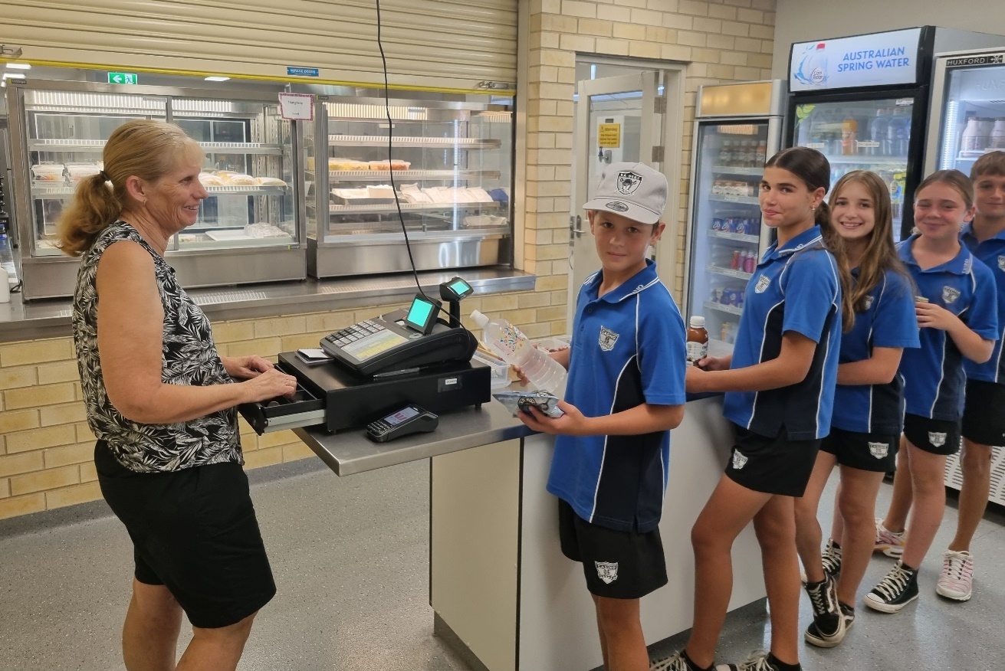

Canteen Price List 2024 (subject to change)
The canteen is run as a service to the school by the P & C Association. The canteen operates Monday to Friday, providing a variety of affordable meal, drink, and snack items complying with the NSW Healthy School Canteen Strategy. EFTPOS available and orders to be handed in at the canteen on arrival at school before 9 am. Gluten Free options available upon request.
Sandwiches |  |  | Hot Food
Ham and Tomato | $4.50 |  | Cottage Pie - homemade | $6.00
Ham and Salad | $4.50 |  | Kings' Plain Pie | $4.50
Cheese and Tomato | $4.50 |  | Kings' Chicken Mornay Pie | $5.00
Ham and Cheese | $4.50 |  | Sausage Roll | $3.50
Chicken | $4.50 |  | Pizza Rounda | $3.50
Chicken and Cheese | $4.50 |  | Chicken Goujons - 5 pieces | $3.00
Chicken, Cheese and Tomato | $4.50 |  | Chicken Crackles - 6 pieces | $3.50
Egg | $4.50 |  | Wedges - 4 pieces | $3.50
Curried Egg | $4.50 |  | Pasta | $4.00
Egg and Lettuce | $4.50 |  | Toastie - Ham and Cheese | $4.00
White, wholemeal & multigrain available
Rolls
Ham Salad | $5.00
Chicken Salad | $5.00 |  | Snacks
Salad - no meat | $4.50 |  | Pancakes | $0.60
Wholemeal & white rolls available |  |  | Jam Drops | $0.50
Wraps
Salad - no meat | $3.00 |  | Drinks
Chicken Salad - large | $4.50 |  | Water 600ml | $1.50
Chicken Salad and Chilli Sauce | $4.50 |  | Water 750ml - flavoured | $4.00
Ham Salad | $4.50 |  | Water 1 litre | $3.50
 |  |  | Water 1.5 litres | $4.00
 |  |  | Schweppes Infused Mineral Water | $3.50
Salads – containers |  |  | NORCO Flavoured Milk
Egg Salad - small | $4.00 |  | FM Chocolate/Strawberry 300ml | $3.00
Chicken Salad - small | $4.50 |  | FM Chocolate 500ml | $4.00
 |  |  | REAL Chocolate/Strawberry 500ml | $4.00
BBQ Chicken Salad - large | $5.00 |  | Plain Milk | $2.50
Chilli Chicken Tender Salad - large | $5.00 |  | Chocolate/Strawberry 440ml | $3.50
Ham Salad - large | $5.00 |  | NIPPY'S Flavoured Milk
 |  |  | Chocolate 500ml | $4.00
 |  |  | Chocolate 375ml | $3.50
Sushi (Monday) - small | $4.50 |  | Chocolate 250ml | $2.50
Sushi (Monday) - large | $5.50 |  | UP & GO Chocolate/Vanilla 250ml | $3.00
Jelly and Custard | $2.50 |  | Juice Bomb 250ml | $2.50
Fruit Salad | $2.50 |  | Slush Puppie - small | $2.00
 |  |  | Poppers - five flavours | $2.00
Hot Food |  |  | Apple Juice 500 ml | $3.50
Hamburger - Monday | $5.00 |  | Iced Tea Peach/Lemon | $3.50
Chicken Burger - Monday | $5.00
Cheeseburger - Monday | $4.50 |  | Chips
Beef and Gravy Roll - Tuesday | $5.00 |  | Sea Salt 27g | $1.50
Nacho's - Wednesday | $4.00 |  | Grain Waves 27g | $1.50
Burritto (Pork) - Thursday | $5.50
Pizza - Friday | $3.00 |  | Ice Blocks
Fried Rice - homemade | $4.00 |  | Chocolate/Sour Ice Mony | $1.00
Quiche - homemade (no pastry) | $3.50 |  | Frozen Fruit Stick | $0.80
Lasagna - homemade | $5.00 |  | Vanilla Ice-cream Cup | $1.50
Butter Chicken and Rice | $6.00 |  | Moosie Chocolate/Blue Moon | $1.50
Spaghetti Bolognese - homemade | $6.00 |  | Juicy Tube Tropical | $1.50
 |  |  | Paddle Pops | $2.00

EVERY DAY COUNTS…
A day here or there doesn’t seem like much, but…
Give your child every chance to succeed…
Every Day Counts!
When your child misses just… | That equals… | Which is… | And therefore, from Kindy to Year 12, that is… | This means that the best your child can achieve it…
1 day each fortnight | 20 days per year | 4 weeks per year | Nearly 1 ½ years of school | Equal to finishing Year 11
1 day a week | 40 days per year | 8 weeks per year | Over 2 ½ years of school | Equal to finishing Year 10
2 days a week | 80 days per year | 16 weeks per year | Over 5 years of school | Equal to finishing Year 7
3 days a week | 120 days per year | 24 weeks per year | Nearly 8 years of school | Equal to finishing Year 4

EVERY MINUTE COUNTS…
When your child misses just… | That equals… | Which is… | And therefore, from Kindy to Year 12, that is…
10 minutes a day | 50 minutes of learning each week | Nearly 1 ½ weeks per year | Nearly 1 ½ a year of school
20 minutes a day | 1 hour & 40 minutes of learning each week | Nearly 2 ½ weeks per year | Nearly a year of school
½ hour a day | ½ a day of learning each week | 4 weeks a year | Nearly 1 ½ years of learning
1 hour a day | 1 whole day of learning each week | 8 weeks per year or nearly a term a year | Over 2 ½ years of learning
Your child’s best learning time is at the beginning of the day…
Check the time & Don’t Be Late!

Bell Times

Monday |  | Tuesday |  | Wednesday |  | Thursday |  | Friday
Roll Call | 9:00-9:10 | Roll Call | 9:00-9:10 | Roll Call | 9:00-9:15 | Roll Call | 9:00-9:10 | Roll Call | 9:00-9:10
Period 1 | 9:10-10:10 | Period 1 | 9:10-10:10 | Assembly | 9:15-9:35  Check the time & DON’T BE LATE! | Period 1 | 9:10-10:10 | Period 1 | 9:10-10:10
Period 2 | 10:10-11:10 | Period 2 | 10:10-11:10 | Period 1 | 9:35-10:35 | Period 2 | 10:10-11:10 | Period 2 | 10:10-11:10
Break 1 | 11:10-11:45 | Break 1 | 11:10-11:45 | Break 1 | 10:35-11:10 | Break 1 | 11:10-11:45 | Break 1 | 11:10-11:45
Period 3 | 11:45-12:45 | Period 3 | 11:45-12:45 | Period 2 | 11:10-12:10 | Period 3 | 11:45-12:45 | Period 3 | 11:45-12:45
Period 4 | 12:45-13:45 | Period 4 | 12:45-13:45 | Period 3 | 12:10-13:10 | Period 4 | 12:45-13:45 | Period 4 | 12:45-13:45
Break 2 | 13:45-14:20 | Break 2 | 13:45-14:20 | Break 2 | 13:10-13:45 | Break 2 | 13:45-14:20 | Break 2 | 13:45-14:20
Period 5 | 14:20-15:20 | Period 5 | 14:20-15:20 | Sport | 13:45-15:20 | Period 5 | 14:20-15:20 | Period | 14:20-15:20

Casino High School
90 Queensland Road
Casino NSW 2470
Phone: 02 6662 3077
Email: casino-h.school@det.nsw.edu.au
Website: casino-h.schools@nsw.gov.au
Casino High School
90 Queensland Road
Casino NSW 2470
Phone: 02 6662 3077
Email: casino-h.school@det.nsw.edu.au
Website: casino-h.schools@nsw.gov.au

